## **Angular Lab - Crud Application**

## Follow these steps and create a CRUD(create, read, update, delete) app in Angular :

* Step 1 – Create New Angular App
* Step 2 – Install Bootstrap
* Step 3 – Create Module with Routing
* Step 4 – Create Component For Module
* Step 5 – Adding Routes
* Step 6 – Create Interface
* Step 7 – Create Services
* Step 8 – Add Code in Component and Template
* Step 9 – Import to Modules
* Step 10 – Start Angular App

### **Step 1 – Create New Angular App**

## First of all, open your terminal and execute the following command in it to install angular app:

### 

### **Step 2 – Install Bootstrap**

In this step, execute the following command in the terminal to install bootstrap:



After that, import this css file into angular 11/12 crud app:

****src/styles.css****

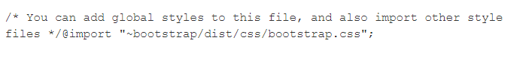

### **Step 3 – Create a Module with Routing**

In this step, execute the following command in the terminal to create module in angular 11 app:



The above given command will create files in the following locations:

src/app/post/post.module.ts

src/app/post/post-routing.module.ts

### **Step 4 – Create Component For Module**

In this step, execute the following commands in the terminal to create components in angular 11 app:

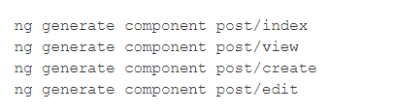

Now, you can see that, the above commands will create some component files into the following locations:

src/app/post/index/*

src/app/post/view/*

src/app/post/create/*

src/app/post/edit/*

### **Step 5 – Adding Routes**

In this step, visit the ****src/app/post directory and open post-routing.module.ts**** Then add the routes into ****post-routing.module.ts**** file:

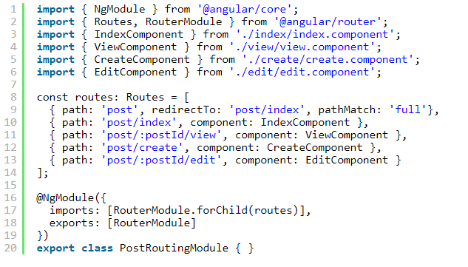

### **Step 6 – Create Interface**

Now, execute the following command in the terminal to create an interface:



Then visit ****src/app/post directory and open post.ts****. And add the following code into it:

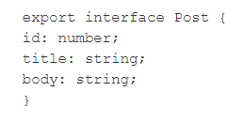

### **Step 7 – Create Services**

In this step, execute the following command to create services:



After that, visit ****src/app/post directory and open post.service.ts****. Then add the following code into it:

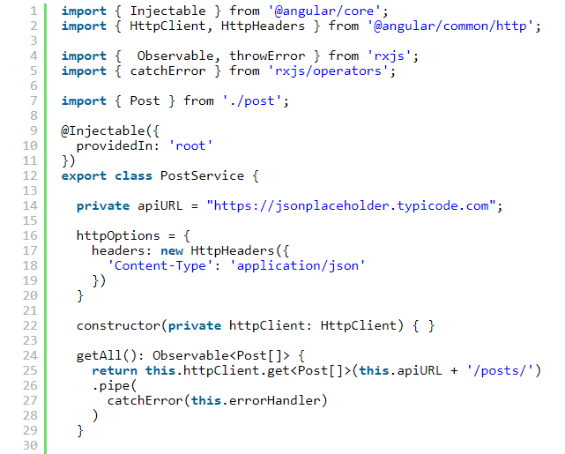

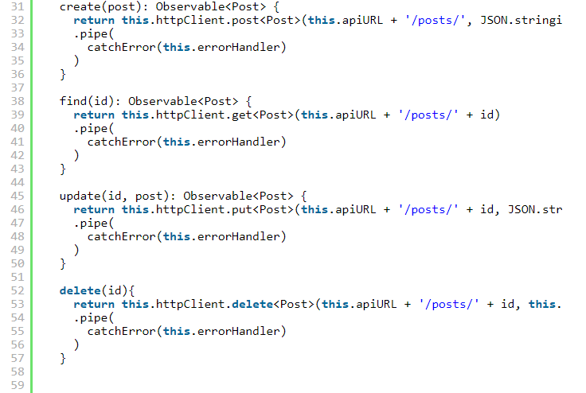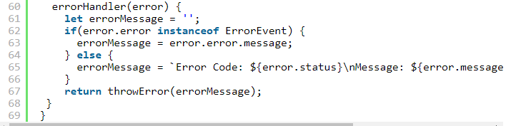

Note that, In this example, we will use [https://jsonplaceholder.typicode.com](https://jsonplaceholder.typicode.com/" \t "https://www.tutsmake.com/angular-11-crud-application-tutorial-example/_blank) web site api.

### **Step 8 – Add Code in Component and Template**

In this step, Create components and template like list page, create page, edit page and view page in angular 11/12 crud app.

#### **1) List Page Template and Component**

First of all, visit ****src/app/post/index directory and open index.component.ts**** or create index.components.ts, if it doesn't exist. Then add the following code into it:

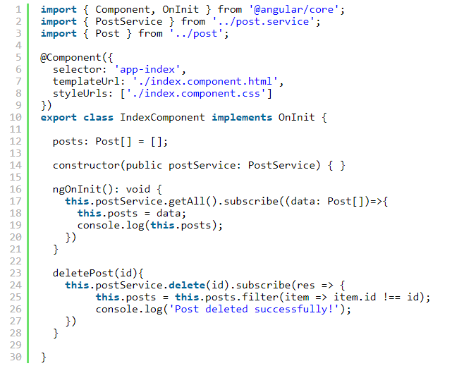

Now, visit ****src/app/post/index directory and open index.component.html**** or create index.component.html, if it doesn't exist. Then add the following code into it:

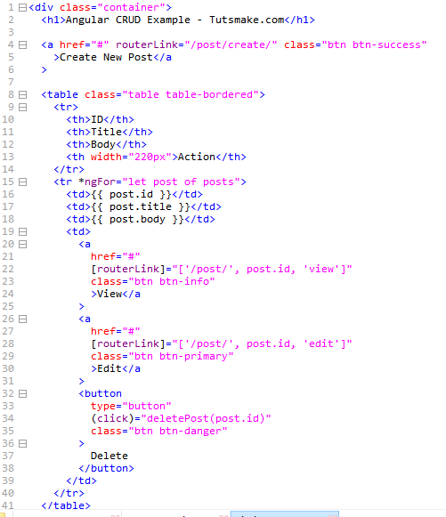



#### **2) Add Post Page Template and Component**

First of all, visit ****src/app/post/create directory and open create.component.ts**** or create create.components.ts, if it doesn't exist. Then add the following code into it:

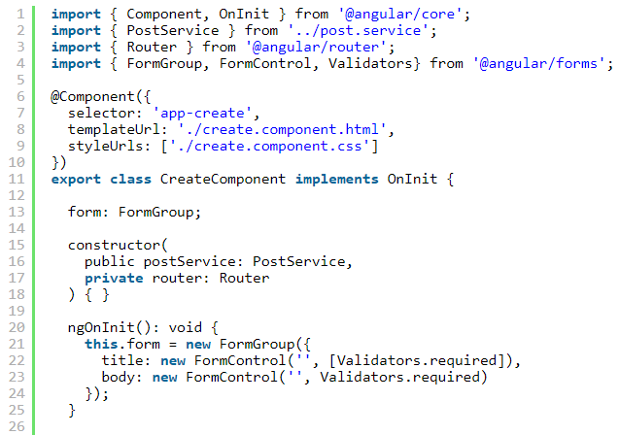

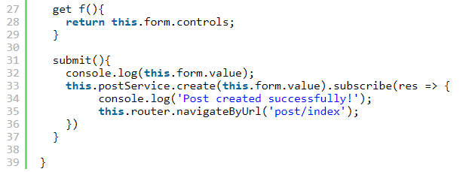

Now, visit ****src/app/post/create a directory and open create.component.html**** or create create.component.html, if it doesn't exist. Then add the following code into it:

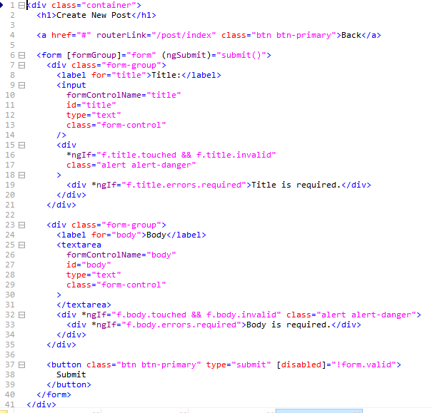

#### ****3) Edit Page Template and Component****

First of all, visit ****src/app/post/edit directory and open edit.component.ts**** or create edit.components.ts, if it doesn't exist. Then add the following code into it:

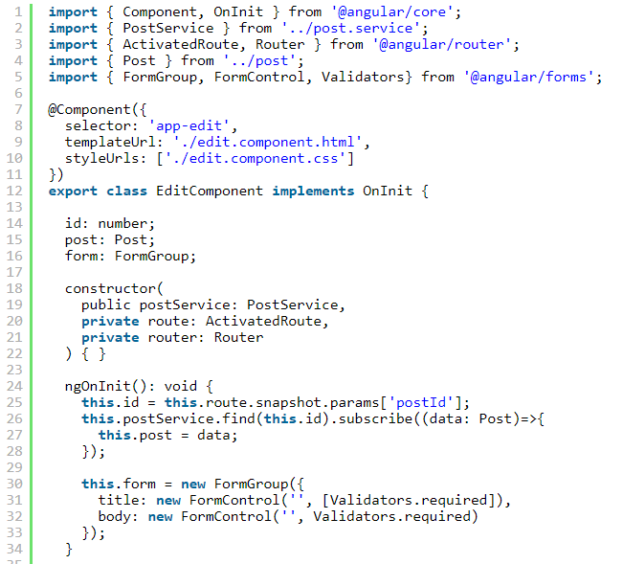

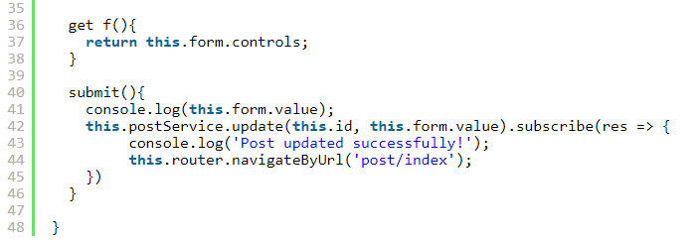

Now, visit ****src/app/post/edit a directory and open edit.component.html**** or create edit.component.html, if it doesn't exist. Then add the following code into it:

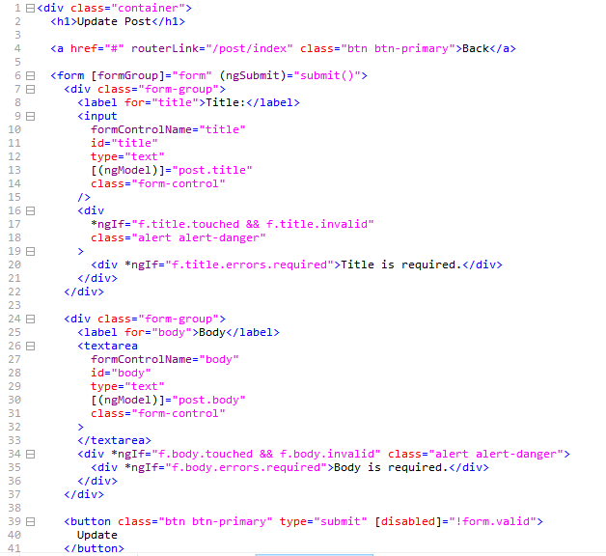

#### ****4) Detail Page Template and Component****

First of all, visit ****src/app/post/view directory and open view.component.ts**** or view.components.ts, if it doesn't exist. Then add the following code into it:

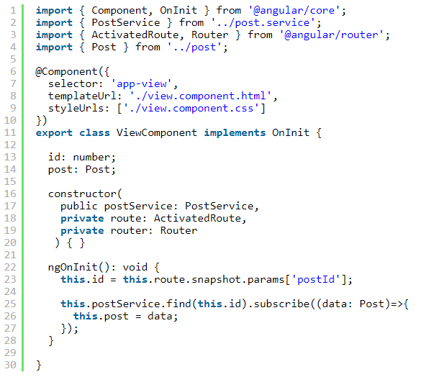

Now, visit ****src/app/post/view a directory and open view.component.html**** or create view.component.html, if it doesn't exist. Then add the following code into it:

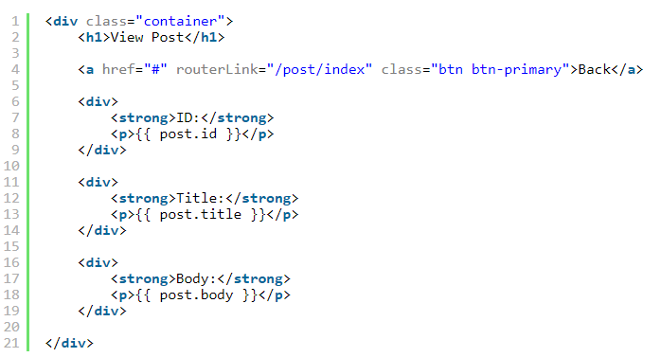

Now, visit ****src/app directory and open app.component.html****. Then add the following line into it:



### **Step 9 – Import to Modules**

In this step, Now, visit ****src/app directory and open app.module.ts****. Then add the following line into it:

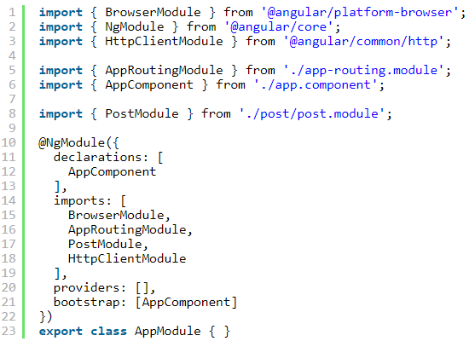

And visit ****src/app/post directory and open post.module.ts****. Then add the following line into it:

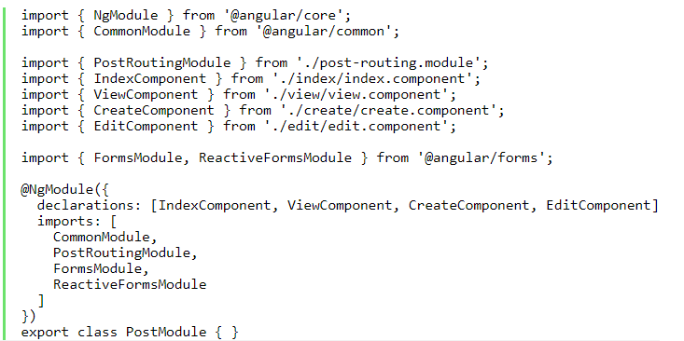

### **Step 5 – Start Angular App**

In this step, execute the following command on terminal to start angular app:



Then open your browser and hit the following url on it:



********************************************************************************************************************************